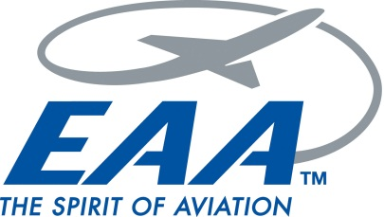
Experimental Aircraft Association

Chapter 501, Lincoln Park, New Jersey

MEMBERSHIP APPLICATION

THANK YOU for your interest in EAA Chapter 501! If you have not already done so, please join us at one of our monthly meetings. To join the Chapter you must also be a member of the EAA national organization. EAA National dues currently are $40.00 per year. For more information go to www.eaa.org Also, payment of annual dues to Chapter 501 is a condition of membership (and is just about our only source of income). The annual dues payment is $35.00 for an individual, or $45.00 for a family membership. After July 1, dues for new members are prorated by month. Make checks payable to “EAA Chapter 501.”

Name(s) _Click here to enter name.

Address _Click here to enter address.
Click here to enter more address.

Preferred telephone: (Indicate home/work/cell) _Click here to enter phone number.

EAA National Membership Number(s) _Click here to enter text.

Email Address(es): _Click here to enter email address.

How did you find out about EAA Chapter 501? _Click here to enter text.
Click here to enter more text.

If you are a licensed pilot, what ratings? _Click here to enter ratings.

If you are an aircraft owner or member of a flying club, what, where, N#? Click here to enter aircraft data.

Please email the completed application to: Membership Chairman Paul Schulman at paulschulman1@verizon.net and copy Chapter President Matt Lamm at lamm.matthew@gmail.com or send via USPS mail to: Paul Schulman, 9-15 Norma Avenue, Fair Lawn, NJ 07410-1704.

Questions? Contact any officer listed on our website at http://www.eaa501.org

